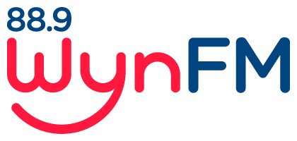

SOCIAL MEDIA

POLICY

Community Radio Broadcasting
Codes of Practice: Code 3: General Programming

Review: October 2021

WYNFM SOCIAL MEDIA POLICY

1. Aim

This policy aims to ensure that all members and announcers of WynFM Community Radio Inc. understand the implications and potential for harm that participation in Social Media can have on the station.

Social Media covers a wide range of activities and services such as Facebook, Twitter, YouTube, My Space, Wikipedia, Internet forums and many apps, websites and platforms.
This policy recognises that as technology changes, there may be other forms of sharing social media and social networking, and this policy will cover any forms of sharing social information by any medium or by any internet site or by any other known or devised site when this policy was formulated.

2. Guidelines and responsibilities

If you are posting on social media under WynFM’s name or a show broadcast through WynFM, you are representing the Station – just as you are doing if you are on air.

If you are representing the Station or involving the Station in your post , you are not permitted to post:

- Anything with the potential to be perceived as bullying, discriminatory, defamatory, hateful, obscene or otherwise offensive – such as vulgarity, slander or libel, ethnic, religious or racial slurs.

- Advertising

- Other member’s personal information

- Confidential WynFM information such as financial details

- Content irrelevant to the station

- Misleading or clearly incorrect information

- Personal opinions, in such a way that they may be misconstrued as the stations official position on a matter

- Any photographs that are connected to the Station without permission from all the people depicted in the photograph

- Anything that undermines the interest or reputation of WynFm Community Radio or its members

Please consider that not everything that you see on the internet is appropriate for rebroadcast or posting on WynFM social media platforms.

Some items may be better suited for your own personal accounts.
When in doubt, do not post.

When posting on your personal account or other platforms unassociated with WynFM , the guidelines do not apply.

However, if you identify WynFM and your connection to it in a private post, you will be subject to this social media policy.

3. Consequences of breaching this policy

If the Committee of Management determines there has been a breach of this policy, it will result in disciplinary action ranging from a verbal warning to termination of membership

Of course, State and Federal law also applies and may also be a consequence of breaching this policy.

Documents related to this Policy:

Community Broadcasting Codes of Practice: Code 3: General programming

WYNFM Community Radio Inc Constitution

WYNFM Community Radio Inc Policies
- Volunteer Policy
- Complaints Policy
- Internal Conflict and Grievance Procedures
- Privacy Policy [Not yet ratified]
- Diversity Policy
- Health and Safety Policy

