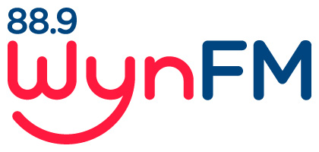

MUSIC POLICY

Community Radio Broadcasting Codes of Practice:
Code 5: Australian Music

Review: April 2022

WYNFM MUSIC POLICY

BACKGROUND

One of the prime motivations of community broadcasters is supporting local, independent and particularly, Australian Music.
Community broadcasters are in a unique position to play and engage with a broad range of musical styles.
This support of the music industry and diverse music played, is one of the key reasons people listen to community radio.
] The 2006 McNair Audience Research Survey shows that 2 key reasons for listening to community radio stations are:
- They play Australian Music / support local artists
- Specialist music or Information programs

PURPOSE

The purpose of this policy is to ensure that WYN_FM Community Radio
- continues to play a diverse range of music throughout all of its programming
- supports local musicians
- complies with the 25% Australian music requirement of the Codes Of Practice by aiming for 30% Australian music across all general programming.
This allows for specialist programs [ethnic and / or talk based] which may not be able to meet the 25% quota[see #2 under Policy]

POLICY

- Broadcasters are encouraged to provide a wide range of musical styles while taking into account the station’s aims and objectives and the individual programs aims and objectives

- All programs will endeavour to ensure that of the total music played throughout a program, at least 30% of this is Australian unless
i. the program’s aim is to focus on music or culture other than
Australian
ii. the music style of a program is of a nature that does not have a high
instance of Australian recordings.

3. In the case of 2i and 2ii, prior approval must be given by the programming
committee for a program to qualify for these exemptions.

- WynFM members must not use the internet to relay content into
their shows through services such as youtube.com, vimeo.com,
spotify, or similar audio or streaming services, unless they can
prove that they own the rights to the source material or have paid
for that content directly.

- All Australian recordings that are the property of the station will be visibly
identified as Australian
- To ensure that we meet content quota’s, an audit of all music broadcast on WYNFM will be conduced on an annual basis, with presenters identifying Australian content.

- Presenters are encouraged to, within the confines of the Sponsorship Policy, promote events where local musicians are featured.

- Presenters must not make representations to record companies or other music suppliers on behalf of WynFm Community Radio unless prior consent has been given by the Committee of Management.

- WynFm Community Radio will not accept any form of payment in cash or in-kind, in return for providing airplay or promotion of music, except under approved sponsorship agreements.

Documents relating to this Policy

Community broadcasting Codes of Practice: Code 5: Australian Music

WynFM Community Radio Inc Constitution

WynFM Community Radio Inc Policies
- Volunteer Policy
- Sponsorship Policy
- Computer and Internet Usage Policy
- Programming Policy
- Sponsorship Policy

