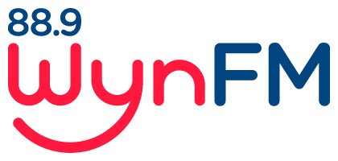

DRUGS AND ALCOHOL Policy

Community Radio Broadcasting Codes of Practice
Code 1.4: Written policies that outline rights and responsibilities of financial
members

Review: June 2022

WYNFM Drugs and Alcohol policy

WynFM will do its utmost to create and maintain a safe, healthy and productive workplace for all members.
We have a zero-tolerance policy in regards to
- the use of illicit drugs on the premises
- attending the station to present a program whilst under the influence of illicit drugs
- alcohol intake on the premises
- attending the station to broadcast a program whilst under the influence of alcohol

Contravening either of these points will lead to disciplinary procedures including termination of your membership.

Documents relating to this policy
Community Radio Broadcasting Codes of Practice
Code 1.4[b] Written policy documents that outline rights and responsibilities of financial
members.

WYNFM Community Radio Inc Constitution

WYNFM Community Radio Inc Policies
- Volunteer Policy
- Internal Conflict Resolution Policy
- Health and Safety Policy
- Complaint Policy

