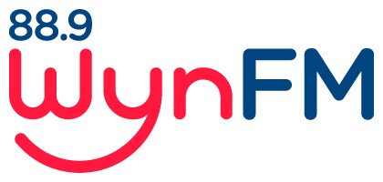

Computer and Internet Usage Policy

Community broadcasting Codes of Practice
Code 3: General Programming
Code 7: Complaints

Review: June 2021

WYNFM Computer and Internet Usage
Policy

WynFM is welcoming and we seek to include Members from all areas of our community.

- Background

WynFM’s computers and Internet services are recognised as powerful communication tools for today's radio and business community. Their use can significantly increase productivity. However, if misused, they can be detrimental to our operation.

- Acceptable Usage

The acceptable use of the station’s Computers and Internet services are solely for WynFM’s supported operational purposes. As such, the access to and use of the variety of Internet services are considered a privilege and should be treated as such by all members of WynFM.

- Unacceptable Usage

In brief, WynFM characterises as unethical and unacceptable, any activity which purposely:
- seeks to use WynFM’s computers and Internet services for private or personal business;
- is in conflict with the Act and/or our polices and procedures as set out in this Manual; and
- disrupts the intended use of the computers and Internet at our station.

WynFM members must not use the internet to relay content into their shows through services such as youtube.com, vimeo.com, spotify, or similar audio or streaming services, unless they can prove that they own the rights to the source material or have paid for that content directly.

WynFM members must not store files, send messages, access sites or print materials that are:

- offensive, indecent, obscene, menacing, violent or abusive;
- intended to incite criminal activities or instruct others in how to commit criminal activities;
- pornographic, obscene or contain suggestive material; or
- could otherwise be considered objectionable.

Objectionable material may include:
- Sexually explicit messages, images, cartoons or jokes;
- Unwelcome propositions, requests for dates or love letters;
- Profanity, obscenity, slander or libel;
- Ethnic, religious or racial slurs;
- Political beliefs or commentary;
- Comments on the physical appearance of other members of staff, whether they are a recipient of the message or not;
- Comments of a sexual, sexist or racist nature, or make inferences or comments about a person's sexual preferences; or
- Degrading comments, whether based on race, disability, sex etc.

WynFM reserves the right to monitor all computer and Internet related activity occurring through the station’s computer network.

Any WynFM members found in violation of this policy will be subject to disciplinary action including termination of membership.

Documents related to this Policy:
Community Broadcasting Codes of Practice:
Code 3: General programming
Code 7: Complaints
WYNFM Community Radio Inc Constitution
WYNFM Community Radio Inc Policies
- Volunteer Policy
- Internal Conflict and Grievance Resolution Policy
- Complaint Policy
- Programming Policy
- Music Policy
- Diversity Policy
- Health and safety Policy

