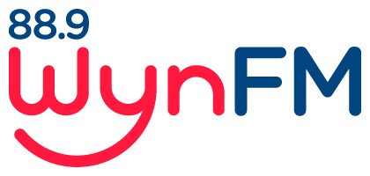

COMMUNITY
PARTICIPATION
POLICY

Community Radio Broadcasting Codes of Practice
Code 2: Principles of diversity and independence

Review: July 2022

WYNFM COMMUNITY RADIO INC

COMMUNITY PARTICIPATION POLICY

RATIONALE: The main purpose of WYNFM Community Radio Inc. is to provide a service to the general community, not only through entertainment, but to build community spirit through the promotion of community organisations and their activities .
This involves making the studio open to participation by members of the community, both as individuals and as representatives of organisations.

ENTERTAINMENT:
Basic Principles:
- In any community, musical tastes vary widely. Over the course of a fortnight, 3WYNFM provides a wide spectrum of music-based programs to cater for these tastes•
- Programming content will not at any time express prejudice on the basis of ethnicity, race, language, gender, sexuality, age, physical or mental ability, occupation, religious, cultural or political beliefs.

COMMUNITY BUILDING:
WYNFM Community Radio Inc. sees itself as an active part of the community it serves. The
participation is two-way.
1. Through Open Days and invitations, members of the community are welcome to visit the studio at any time, and may observe programs going to air, and enjoy a guided tour of the studios. They will be encouraged to volunteer their services to WYNFM Community Radio Inc. in whatever role is appropriate to their skills and interests.
2. Membership will be open to all who apply, subject to WYNFM’s Constitution and Membership Policies. There will be no discrimination against persons on grounds of ethnicity, race, language, gender, sexuality, age, physical or mental ability, occupation, religious, cultural or political beliefs.
3. Training for a variety of roles in the organisation will be provided .
4. Not-for-Profit organisations will have access to free programming, whether of community service announcements, interviews or regular programs.
5. Listeners and members have the right to query policy and comment on program quality and content and receive a positive response.
6. WYNFM Community Radio will take an active part in local events such as Festivals and Expos.
7. WYNFM Community Radio will join local groups such as Business Groups, and use their contacts within other not-for-profit organisations to expand membership, participation and service provision.
8. WYNFM Community Radio will provide volunteers for local events such as Weerama.
9. WYNFM Community Radio Inc. will continue to use a variety of ways to encourage community participation in the wider operations of the organisation

Documents Related to this Policy:

Community Radio Codes of Practice: Code 2.1Principals of Diversity and Independenca
WynFM Community Radio Inc Constitution
WYNFM Community Radio Inc. Policies
- Volunteer Policy
- Membership Policy
- Programming policy
- Music Policy
- Health and Safety Policy
- Complaints Policy
- Internal Conflict Policy
- Diversity Policy
- Anti Discrimination and Harassment Policy
- Anti bullying Policy
- Social media Policy

